**Temasek Polytechnic**

**School of Informatics & IT**

**Software Engineering (CIT3C14)**

**AY 2018/2019 Oct Semester**

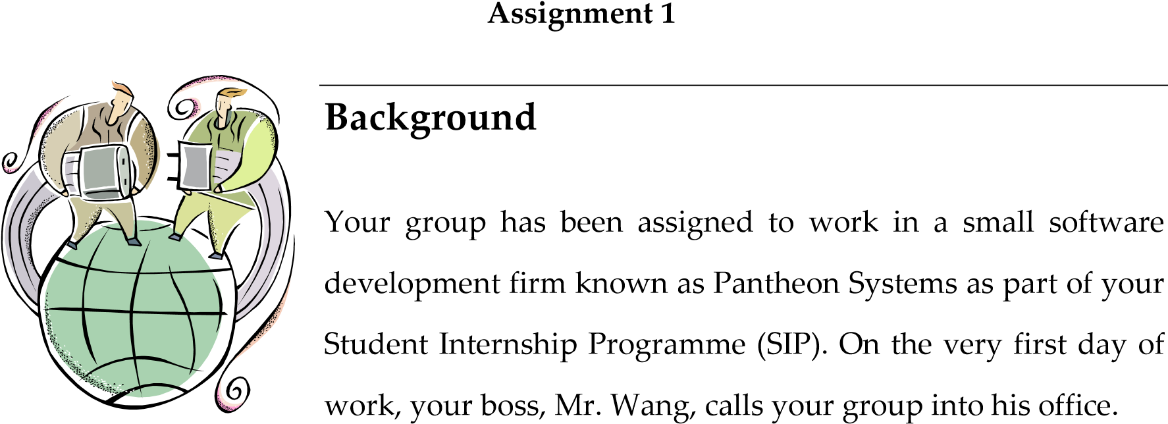

Mr. Wang states the following:

“Last year, a group of students from Temasek Polytechnic —School of Informatics & IT worked on a personal information management system for Sonium. Despite the huge challenge faced, the team managed to deliver a working system successfully. I was quite pleased with their achievement, and expect your group to attain the same in the new project that I will be assigning you.

This new project concerns the development of a hotel management system for Delonix Regia. The hotel is currently managed by a middle-aged couple, Mr. and Mrs. Wang, and hasn’t been doing well even though it is located at a reasonably good district.

Mr. and Mrs. Wang have engaged us to produce the following deliverables for the project as a

start:

1. Terms of Reference (TOR)
2. Project Plan

They had also indicated their expectations to have an update on the project progress periodically.

Now, you’ll need to talk to Mr. and Mrs. Wang to gather more requirements on this system. In the meanwhile, do check out other available hotel web sites to get more ideas. You’re only given

17 weeks to complete this project. Now, get to it.”

# Project Deliverables

The following deliverables are to be produced by 2359hrs 18th November 2018, Sunday: Submit by Leader*

1. A short description to explain the meaning of Software Development Life Cycle (SDLC). Do ensure that you include three (3) software development models in

your explanation. [5 marks - Individual]

1. Terms of Reference (TOR) Document - To use the template provided [2.5 marks

– Individual, 2.5 marks - Group]

1. Project Plan - To use the template provided [7.5 marks – Individual, 2.5 marks -

Group]

# Grading

This assignment constitutes 25% of your overall grade; 20% will be assessed individually, while the remaining 5% will be assessed as a group.

**Subject Rubrics:**

|  |  |  |  |  |
| --- | --- | --- | --- | --- |
| **S/No** | **Project Deliverables** | **Marks**  **Allocated** | **Requirement** | |
| 1 | A short description to explain the meaning of Software Development Life Cycle (SDLC).    Do ensure that you include three (3) | 5 marks -  Individual | * Definition of SDLC * Phases in SDLC * Cite three (3) software development models and its working concept * Application of any theoretical mentions to project | |
|  | software development models in your explanation |  |  |  |
| 2a | Terms of Reference  (TOR) Document | 2.5 marks –  Individual | • | Address for points stated in the template for each of the section. |
|  |  |  | • | Application of any theoretical mentions to project |
| 2b | Terms of Reference  (TOR) Document | 2.5 marks -  Group | •  • | Adhere to template given  Even workload distribution |
|  |  |  | • | Linkage and flow of information between all sections |
|  |  |  | • | Team / Peer Evaluation |
| 3a | Project Plan | 7.5 marks –  Individual | • | Address for points stated in the template for each of the section. |
|  |  |  | • | Application of any theoretical mentions to project |
| 3b | Project Plan | 2.5 marks -  Group | •  • | Adhere to template given  Even workload distribution |
|  |  |  | • | Linkage and flow of information between all sections |
|  |  |  | • | Team / Peer Evaluation |
| 4 | Q&A(on the two (2) deliverables on TOR and Project Plan. Each team member will be given at most 5 minutes for the Q&A session.) | 5 marks -  Individual |  | * Speech Delivery i.e. Confidence / Fluent / Command of Language + Eye Contact. * Equal contribution to overall work, significant proof of own work. * Response to questions asked. |

**\*\*\*\*\* End of Assignment 1 \*\*\*\*\***